



Computer Communications 27 (2004) 751–761

Modeling mobility and workload

www.elsevier.com/locate/comcom

for wireless metropolitan area networks^{q}

Matthias Hollick^{a,}*, Tronje Kropa, Jens Schmittª, Hans-Peter Huth^{b}, Ralf Steinmetzª
aMultimedia Communications Lab (KOM), Faculty of Electrical Engineering and Information Technology,
Darmstadt University of Technology, Darmstadt, Germany
bDepartment of Information and Communications, Siemens AG, Corporate Technology, Munich, Germany
Received 23 October 2003; accepted 24 October 2003

Abstract
Research on large-scale wireless metropolitan area networks, which offer broadband capacity while supporting user and terminal mobility
suffers from the lack of realistic mobility and workload models. There is a strong need for such models to be able to perform sound
simulations supporting important yet difﬁcult tasks like network planning and trafﬁc engineering. In this paper, a novel approach towards
realistic modeling of user mobility is proposed and studied. We formulate an analytical model, which is a hybrid of an empirical mobility
model and a synthetic trafﬁc model. The model clearly separates the inﬂuence of mobility and trafﬁc to allow for greater ﬂexibility.
The mobility part is based on the combination of statistical zoning information with ﬁeld data of movement patterns. This allows us to predict
the density of users—classiﬁed into different groups—for a given area at a given time. We are able to integrate different trafﬁc characteristics
on top of our mobility model elegantly. The combination of user density with the predicted—synthetic—trafﬁc of the modeled user groups
gives the trafﬁc and ﬂuctuations of trafﬁc throughout the network, thus describing the workload for the envisioned scenario. We present the
instantiation of our model for the example of a real city. Analysis and simulations are provided which show that the proposed scheme is quite
prospective. Our ﬁndings are, that our model is able to cover the macroscopic effects of real-world behavior more precisely than currently
available mobility/workload models.
q 2003 Elsevier B.V. All rights reserved.
Keywords: Mobile communications; Wireless communication networks; Mobility modeling; Workload modeling; Metropolitan area radio access networks

1. Introduction

With the advent of the Internet, the quality of personal
communications has changed signiﬁcantly. The avail-
ability of a nearly ubiquitous communication platform and
simple yet useful applications like e-mail, news or more
recently instant messaging has attracted millions of users.
Moreover, in a broader sense, the last century was
signiﬁcantly inﬂuenced by a trend towards personal
mobility for the masses. The intersection of these
trends gave birth to the area of mobile and wireless
communication networks.

q
This work is partially funded by Siemens AG, CT IC 2 within the
MobQoS project. More information may be obtained at http://www.kom.
tu-darmstadt.de/Research/MobQoS.
* Corresponding author. Tel.: ю 49-6151-166158; fax: ю49-6151-
166152.
E-mail address: matthias.hollick@kom.tu-darmstadt.de (M. Hollick).
0140-3664/$ - see front matter q 2003 Elsevier B.V. All rights reserved.
doi:10.1016/j.comcom.2003.10.015

Today multiple technologies and frameworks compete
for the market to support mobile communications: after the
success of second generation cellular networks, the third
generation speciﬁed within the IMT2000 framework is
currently being deployed. On the other hand, there is a
tremendous effort to build large-scale wireless networks
based on wireless local area network technology—
especially in the context of high-capacity usage. We think
both technologies will proliferate—each one complement-
ing the other for special applications—to fulﬁll both
demands: personal mobility combined with ubiquitous
communication capabilities at optimized trafﬁc rates.
These concepts are the foundation of fourth generation
networks and the wireless Internet, embracing a hetero-
geneous set of radio access technologies, which gives rise to
several interesting research challenges.
Induced by user and device mobility—while
tightly coupled to usage and application-speciﬁc trafﬁc

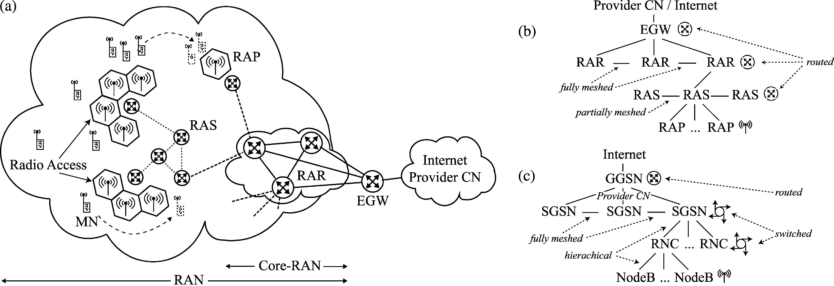

752

M. Hollick et al. / Computer Communications 27 (2004) 751–761

patterns—future wireless metropolitan area networks will
experience heavily varying loads on different timescales.
Our goal is the investigation of resource management
issues to deal with the predicted trafﬁc demand of these
networks. Here, we concentrate on solutions based on QoS
routing mechanisms (see, for example, Refs. [1 – 3]).
The system boundaries for our analysis are deﬁned by
the MobQoS scenario [4], which is derived from
various concepts of the Internet communities and tele-
communication industries [5 – 9].
We assume a three-tier architecture as depicted in
Fig. 1(a). The mobile nodes (MN) or terminals are
associated to wireless base stations, the so-called radio
access points (RAP) representing the last hop of the
provision network. The function of the ﬁrst tier thus can
be described as radio access. The second tier, the radio
access network (RAN), comprises radio access servers
(RAS), which are used to attach multiple RAPs. The RAS
are meshed with neighboring systems and thus allow the
start of resource management at this level. The core of the
second tier is built by radio access routers (RAR).
Between selected RAS and RAR there are uplinks.
The transition to the third tier of the architecture, the
core provider network, respectively, the Internet, is
performed by one or more edge gateways (EGW).
This scenario reﬂects the paradigm change from strictly
hierarchical topologies (see Fig. 1(c)), which are nearly
homogeneous with respect to cell sizes and capacity in
today’s personal communication (PCS) networks, towards
highly variable and meshed topologies including high
bandwidth micro and pico cells. We assume our network
to be a routing network beginning at RAS level as well
(see Fig. 1(b)). Additionally, the set of applications used
within such networks will yield different network trafﬁc as
in today’s cellular networks—from constant bitrate voice
communication towards a more Internet-like heterogeneous

mix of trafﬁc. Hence, we believe that today’s mainly static
resource management approaches need reconsideration.
Our work in the area of QoS routing protocols to allow
for improved resource management concentrates on the
effects induced on the data plane by user mobility.
From these investigations, we derive the need for a more
ﬂexible and realistic mobility model than available in
literature. As we will show, current mobility models suffer
from various limitations: they are mostly restricted by the
call- and connection-oriented paradigm of traditional
cellular networks and lack the necessary degree of freedom
and ﬂexibility to reﬂect the future networks and services we
want to investigate.
Our contribution lies in a novel mobility/workload model
for wireless metropolitan area networks. We present in
detail the fundamentals of our model, which is ﬂexible with
respect to parameterization of the user behavior while
maintaining reasonable complexity. The model introduces a
generic classiﬁcation of locations and user behaviors, which
allow the derivation of the aggregated effects of user
mobility. We present the coupling of our mobility model
with trafﬁc predictions to form a workload model, as well.
We provide the analytical description of the model.
The formalization deﬁnes a toolset, which allows for easy
implementation of our model in real metropolitan
environments. The instantiation of our model is performed
for an area within central Darmstadt, a German city of
approximately 145,000 inhabitants.
The paper is organized as follows. In Section 2, previous
and related work is surveyed. Section 3 describes the
fundamentals of our model. This includes the modeling of
locations and user behavior. Section 4 comprises the
analytical description of our model. We give deﬁnitions as
well as equations to exactly represent the model
assumptions. In Section 5, we present the instantiation of
our model and possible applications for networking

Fig. 1. (a) Scenario for a future wireless metropolitan area network. Conceptional model of: (b) the envisioned topology vs. (c) Traditional second and third
generation topologies. Legend: CN, core network; EGW, edge gateway; GPRS, general packet radio service; MN, mobile node; RAN, radio access network;
RAP, radio access point; RAR, radio access router; RAS, radio access server; RNC, radio network controller; SGSN, serving GPRS support node; GGSN,
gateway GPRS support node.

M. Hollick et al. / Computer Communications 27 (2004) 751–761

753

research. The paper is concluded by summarizing the
main results and discussing aspects of future research in
Section 6.

2. Related work

There are different approaches towards realistic models
for mobile communications. A fairly comprehensive
survey on mobility modeling in wireless networks can
be found in Ref. [10], a more detailed description of
some random models in Ref. [11]. There is, however, no
common scheme to categorize all dimensions of these
models because they are so manifold. Within our work,
we use a broad categorization into two classes:
microscopic vs. macroscopic mobility models, since
these two concepts cover the essential distinction with
respect to our investigation.

† Microscopic mobility models describe the mobility
behavior of individuals. They are often based on
analytical descriptions of user movements.
Most synthetic or random models fall into this class.
† Macroscopic mobility models describe the aggregated
effects of mobility. They are often obtained using
statistical data collection and thus inherently aggregate
the behavior of individuals.

Within our context, we are interested to realistically
model mobility at the scale of a metropolitan area. Given this
viewpoint, we reviewed the following related work.

2.1. Microscopic mobility models

The class of random models is the most prominent
example for microscopic models. Random models describe
the movements of individuals. There are numerous
models including the random walk model, the random
gauss – markov model, the random mobility model, the
markovian model, and the random waypoint model [11].
These models try to provide an exact analytical description
of the behavior of individuals. Random models have been
optimized for accuracy, [10] being one example.
The characteristics of a generalized random model for
cellular networks with respect to mobility patterns are
studied in Ref. [12]. However, these models are not able to
reﬂect macroscopic behavior and often exhibit undesirable
properties if applied improperly [13].
Random models may operate on other levels to reﬂect
group behavior as well [14]. However, the results, neither of
individual mobility nor of group mobility do account for a
city at large. This is mainly due to the mostly homogeneous
nature of random models if aggregated thus leading to fairly
equal distributions for large areas. If we, however, regard a
real city, we observe numerous attractions and hot spots.
These are likely to be crowded during short periods of time

or over day while being empty during the night. It is,
from our perspective, extremely unlikely, that pure random
behavior ﬁts such a scenario. There are some random
models, which can be widely parameterized to match
correct macroscopic behavior as well [15]. The correct
instantiation for these depends on macroscopic models,
nonetheless. Since the microscopic models violate our
assumption of realism at metropolitan scale, we do not
further investigate this class of models.

2.2. Macroscopic mobility models

Macroscopic mobility models try to match the
aggregated user mobility within large areas. Models from
transportation planning are often used as a basis for
large-scale mobility models. TRANSIMS [16] is an
example of a complex synthetical model. It creates a virtual
region with complete representation of individuals and their
activities. The transportation is modeled and trips are
planned to satisfy the individuals’ activity patterns.
The behavior of individuals and the geometrical distribution
of households is derived from census data. The focus of
TRANSIMS is transportation planning. It would be possible
to extend the framework to generate data that ﬁts the needs
of teletrafﬁc modeling for wireless networks. However, this
comes at the expense of a very complex overall framework
which for example tracks the movements of all individuals
and requires very hard calculations and extensive
parameterization.
The comprehensive work of Lam et al. [17] presents and
evaluates teletrafﬁc models for metropolitan, national and
worldwide scale. The work is based on results from
transportation planning. The authors have been able to
show that the model predictions can be validated using real
world data. The focus lies—like in most work in the area of
wireless teletrafﬁc modeling—on the investigation of
control plane issues like location management trafﬁc.
Therefore, the model does not include a distinction into
multiple user types, effectively rendering it unusable for
most parts of our intended model usage, which is coupled to
data trafﬁc.
A general work in the area of teletrafﬁc models for
urban environments can be found in Ref. [18]. The author
investigates various types of cell structures and especially
the inﬂuence of variation in the size of cells. Findings of
Nanda [18] include the relation between handoff rate and
cell size as well as between handoff rate and cell shapes.
Despite the excellent results in the areas investigated, the
work cannot be applied to our scenario, since it does not
provide the necessary detail and ﬂexibility of the user
model. Ref. [19] limits its scope on the location
management aspects of user mobility. However, the
underlying mobility model presented makes uses of more
detailed information of user behavior and activities,
which are not further exploited. Moreover, the work
borrows the concept of trips to describe the intention

754

M. Hollick et al. / Computer Communications 27 (2004) 751–761

and whereabouts of users from work in the area of
transportation modeling.
The work of Rocha et al. [20] uses a mobility model
similar to the one in Ref. [19] and implements a graphical
tool to support analysis of the results. The instantiation of
areas and user behaviors is, however, very coarse and does
not reﬂect realistic environments.
Ref. [21] describes a trafﬁc model for “third generation
cellular mobile telecommunication systems”. Part of this
model is a user mobility model described in Ref. [22],
which is based on the average distance and average
velocity of users. These parameters are estimated for
certain environments including multiple classes of out-
door environments and different vehicles. The work is
limited to the estimation of cell border crosses to predict
handoff rates and call durations. While in Ref. [21] the
geographical instantiation models a manhattan grid model
of a city center using relatively coarse characteristics for
zoning information, Ref. [22] presents background
information on mobility modeling and a comparison to
classic area zone models for teletrafﬁc modeling including
Ref. [23]. Other work in this area includes Refs. [24,25],
which address additional aspects of area zone models and
Ref. [26], which describes a novel stop-or-move mobility
model to address some shortcomings of purely random
models.
Another group of models for large-scale networks relies
on the analysis of existing infrastructures and network
traces. In particular, work which investigates large-scale
wireless radio access topologies for data trafﬁc with respect
to user mobility has been proposed only recently. The work
of Tang and Baker [27] is able to provide deep insights on
user behavior for a metropolitan area wireless network.
The work of Kotz and Essien [28] claims to be the largest
and most comprehensive real world trace of a production
Wireless LAN. The results, however, do account for a
special campus style network and mainly focus on trafﬁc
analysis—the mobility aspect is restricted by the campus
setup and thus cannot be transferred to public networks.
Balachandran et al. [29] concentrate on network
performance of small-scale networks, which are not
representative for the metropolitan scale.
There are two critical points about trace-based
methodologies. First, they only account for services already
deployed and in use and particularly only count ‘early
adopters’. This is especially true if we regard wireless RANs
for data communication at the time of writing. Second, the
results often cannot be separated into mobility and trafﬁc
related parts, thus prohibiting the parametrization of
individual factors for simulation.

2.3. Conclusions

While current approaches including Refs. [17,18] focus
on handoff rates and other parameters coupled to the number
of handovers and user numbers within given cells, they do

not differentiate between different classes of users and trafﬁc
demands. The activity-based mobility models described in
Refs. [19,20,22] provide for some basic mechanisms,
which may be used for our purpose. The formulation of
these models and their instantiation is, however, not
optimized for data trafﬁc analysis but for classical teletrafﬁc
applications.
In summary, random models do not account for mobility
within large areas and the existing macroscopic models are
either too restricted for our purpose or too complex for the
intended application. The empirical studies of wireless
LANs are limited with respect to the strict decoupling of
mobility and trafﬁc. Thus, we decided to develop a novel
model to ﬁt the needs of the described scenario. We borrow
concepts from transportation planning to realistically
cover macroscopic areas, such as, for example, a center of
a large city.

3. Fundamentals

Our model is developed in the context of transportation
and land use modeling [30,31]. We use the well-known
travel demand modeling approach described in Ref. [30]
and also used in previous work including Refs. [19,20,22].
The basic elements of activity based transport modeling
are the trip, which deﬁnes the movement of a user from an
origin to a destination, and the zone, which deﬁnes areas
with a certain attraction level. Trips are based on the
intended behavior of users while zones represent
homogeneous areas with respect to socio-economic charac-
teristics. The size of zones can range from a few hundred
square meters to several square kilometers in size.
This basic model has been used since the 1960s to
forecast travel demand and various techniques and
submodels have been developed for determining the
variables for each of the elements of travel demand
modeling. It is important to keep in mind that the developed
model represents aggregated information of users and zones
only. Thus the model is well-suited for investigations
covering macroscopic effects.

3.1. Trip generation

The trip generation estimates the total number of trips
that depart and arrive in a speciﬁc zone. In particular,
trips are classiﬁed by trip purpose, such as work or
shopping, for example. The purpose is derived from the
intended user behavior. The corresponding trip is scheduled
to a location where this intention can be fulﬁlled, like, for
example, a workplace or shopping mall. The generated
trips need to be distributed to the destination zones
according to the attraction of these zones, which is
determined by socio-economic characteristics. Moreover,
a modal split accounts for different transportation modes
such as car, bike or subway. According to a trip assignment

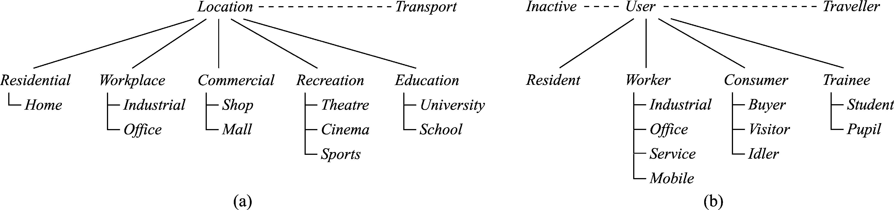

M. Hollick et al. / Computer Communications 27 (2004) 751–761

the individual trips are mapped to the transportation 3.3. Classiﬁcation of users
infrastructure and the best route is calculated.

755

We are primarily interested in the user densities for given
zones. This allows us to omit the determination of modal
splits, trip assignment, and route calculation, which reduces
the model complexity signiﬁcantly. To allow for the
remaining trip generation and distribution, our model
needs to classify locations and user behavior.
Upon instantiation, real world data needs to be ﬁtted to
match this classiﬁcation scheme. Finally, we are able to
calculate the user densities for given zones.

3.2. Classiﬁcation of locations

The classiﬁcation of locations has to reﬂect their
different attraction levels over time. A reasonable
granularity can be reached by assigning a base attraction
level to a zone. The base attraction level is set depending
on basic characteristics of the location. Residential areas
and workplaces (we distinguish into industrial and ofﬁce
workplaces) account for the major ﬂuctuation of users.
Moreover, the attraction of commercial, recreation,
and education facilities is an important factor.
These types of locations are further reﬁned as follows.
Commercial locations include shops and shopping malls;
recreation includes theatres and opera, museums, cinema,
sport events, bars, and pubs. Education places can be
further classiﬁed into schools and universities. A special
location called transport accounts for users on the move.
We assume zones of reasonable size, like those given in
most zoning plans for city development. Moreover, the
zones should be homogeneous with respect to the
attraction of the different locations within each zone,
which is usually also true for public zoning information.
See Fig. 2(a) for a detailed classiﬁcation of locations.
Please note that the classiﬁcation is non-exhaustive to
keep the level of complexity reasonable.
The accuracy of the approach may be increased if extra
information about special places such as shopping malls,
schools, universities, and sights possibly located in the zone
is combined with the base attraction. This reﬁnement comes
at the expense of insider knowledge being necessary,
though.
The most important criterion for the user classiﬁcation is
to adequately characterize the behavior of types of
individuals. The intentions of the resulting groups need to
match the attracting locations as well. The availability of
information about the constitution and behavior of the
derived groups to allow for proper instantiation is another
crucial factor. This includes information to allow for case
discrimination, in particular to predict state transition or
inactivity of users. Resulting from this information, we are
able to predict the aggregated impact of user mobility.
We differentiate the following types of users (roles):
residents, workers, consumers, trainees, and travelers.
Residents are the main group of interest during evening
and at night. We distinguish between inactive residents
(sleeping at home) and active ones (being at home). The role
of a traveler accounts for the state transition between other
states. For example, if a resident departs for a shopping
district, he becomes to a traveler before ﬁnally taking the
role of a consumer.
We discriminate consumers into buyers and visitors in
order to separate shopping activity from leisure. The latter
ones have to be distinguished into daily and nightly
visitors (idlers) to model the different locations of
recreation facilities as for example museums, swim-hall,
and shopping during day or cinemas, theatres, and pubs in
the evening. The numbers for daytime visitors includes
tourists as well.
The number of trainees, namely pupils and students,
usually cannot be neglected, nor can the number of workers.
The class of workers is divided into different sub-classes
which account for different zones in which they perform
their job (commercial zone, industrial zone, etc.) and for
expected differing professional communication behavior
(e.g. mobile personnel use the communication network to
carry out their job while an ofﬁce or industrial worker
communicates in breaks or on his way to/from work).
Besides their function as intermediate state, the travelers
represent the number of people just crossing the investigated
area by car, commuting to external work places or from
external housings to internal workplaces/universities.
See Fig. 2(b) for the classiﬁcation of user behavior.

Fig. 2. (a) Classiﬁcation of locations; (b) classiﬁcation of user behaviors.

756

4. Model

M. Hollick et al. / Computer Communications 27 (2004) 751–761

We use a zone- and behavior-dependent split factor f_{b}a_{р}zЮ to
account for this property. With f_{b}a_{р}zЮ we are able to calculate

Our model distinguishes between user and trafﬁc related
issues. It is based on the classiﬁcation of zones, cells and
locations (see Section 3.2) and the classiﬁcation of users and
the number of users u_{z};b^{р}tЮ within each zone.
u_{z};b^{р}tЮ ј U_{b}рtЮf_{b}a_{р}zЮ

р4Ю

behaviors (see Section 3.3). Using these prerequisites user
mobility can be modeled as follows. Let

Ar ј {residential, workplace, commercial, recreation,
education, transport} denote the set of types of locations.
B ј {resident, worker, consumer, trainee, traveller,
inactive} denotes the set of behaviors.
Z ј {z₁; z₂; …; z_{n}} denotes the set of zones. Zones do not
overlap in space. The union of all zones z_{i}; i ј 1; …; n
covers the whole area of interest.

To allow for a mapping of locations to a cell-based
network infrastructure let
To convert the number of users into the corresponding
activity, we introduce the notion of intensity i_{b}; which
models the fraction of time a user dedicates to communi-
cation purposes. Activity thus denotes the sustained number
of communicating users. For the sake of simplicity, i_{b}may
be combined with the trafﬁc-part of a workload model and
neglected in the mobility part. For maximum ﬂexibility of
the mobility model, it would be possible to introduce a time
and zone dependent version of i_{b}; i_{b}рz; tЮ: The activity is
a_{z};b^{р}tЮ ј u_{z};b^{р}tЮi_{b}ј U_{b}рtЮf_{b}a_{р}zЮi_{b}ј UрtЮf_{b}u_{р}tЮf_{b}a_{р}zЮi_{b}р5Ю
with^{P}z[Z^{f}bªрzЮ ј 1:
We obtain

C ј {c₁; c₂; …; c_{m}} denote a set of cells:
The model should predict the number of users with
behavior b; which can be expected in a zone/cell at given

A_{b}рtЮ ј
X

z[Z

a_{z};b^{р}tЮ ј
X

z[Z
u_{z};b^{р}tЮi_{b}:

р6Ю

time t: Let

U_{b}рtЮ ј the total number of users with behavior b at time
t: u_{z};b^{р}tЮ denotes the time-dependent number of users with
Moreover,
X
AрtЮ ј
b[B

A_{b}рtЮ:

р7Ю

behavior b within zone z:
The next step is the transformation of the results from

U_{b}рtЮ ј
X

z[Z

u_{z};b^{р}tЮ and UрtЮ ј
X

b[B

U_{b}рtЮ

р1Ю
zone to cell level. We use a network model similar to
Ref. [24]. The shape of cells is hexagonal. We assume that p
cells are arranged in р2r 2 1Ю columns. Fig. 3(a) shows that

UрtЮ might vary over time. During night, most users will
be inactive, for example. They change their role to active
residents after getting up and eventually to a worker,
consumer, or trainee. In between they are modeled as
travelers. To account for the fraction of users being active in
a role b, we deﬁne a time-dependent split factor per behavior
f_{b}u_{р}tЮ: In reality, the maximum number of users in the system
is variable, because commuters and travelers may enter and
leave the system over day. To simplify calculations, we
assume a ﬁxed maximum number of users U including all
we obtain r columns of k cells and рr 2 1Ю columns of
рk 2 1Ю cells. The total number of cells can be calculated as
p ј rk ю рr 2 1Юрk 2 1Ю: This cellular structure is overlaid
on the zone-based area of investigation.
To be able to transform the results from zone to cell
granularity, let s_{z}be the size of zone z and s_{c}be the size of
cell c: Let r_{c};z denote the fraction of zone z; which is
covered by cell c: Assuming an equal distribution of
attraction levels within zones, we are now able to transform
the results using
X X

users possibly entering the system. If not present in the
system, these users are modeled as inactive residents, which
do not further contribute to the performed calculations.
a_{c};b^{р}tЮ ј

z[Z
a_{z};b^{р}tЮ
s_{z}
s_{c}r_{z};c;with

z[Z
r_{z};c^{ј}1:
р8Ю

Please note, that f_{b}u_{р}tЮ is independent from the location.
U_{b}рtЮ
Using Eqs. (5) and (8) we can calculate the individual
a_{c};b^{р}tЮ; which forms the user activity matrix A_{c};b^{р}tЮ:

f_{b}u_{р}tЮ ј
U
; with^{X}f_{b}u_{р}tЮ ј 1 for all t
b[B
р2Ю
2
66
a₁;resident^{р}tЮ a₁;worker^{р}tЮ · · · a₁;inactive^{р}tЮ
a₂;resident^{р}tЮ · · · · · · · · ·
3
77

Using f_{b}u_{р}tЮ we calculate
U_{b}рtЮ ј Uf_{b}u_{р}tЮ:
р3Ю
66
A_{c};b^{р}tЮ ј 66
64
...
...
...
...
77
77
75
р9Ю

A_{b}рtЮ denotes the activity of users (that is, they emit
trafﬁc) with behavior b at time t: a_{z};b^{р}tЮ denotes the time-
a_{p};resident^{р}tЮ
· · ·
· · · a_{p};inactive^{р}tЮ

dependent activity of users with behavior b in zone z:
The user population UрtЮ needs to be assigned
corresponding to the attraction of locations within zones.
Please note, that the model described above can easily be
extended to reﬂect more details of user behavior or location
attributes. For example, it would be possible to model

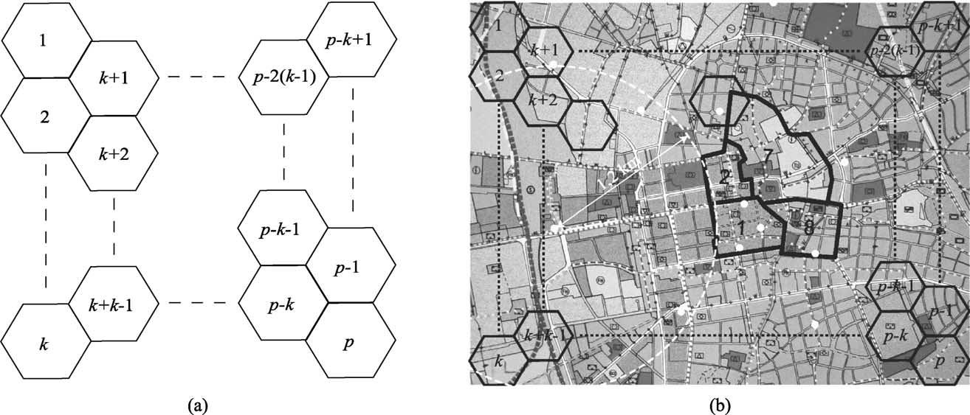

M. Hollick et al. / Computer Communications 27 (2004) 751–761

757

Fig. 3. (a) Network system model; (b) excerpt of the instantiation for Darmstadt, including the modeled cell vs. zone size and comparison to the coverage of the
base stations of an actually deployed GSM network.

the time varying aspects of user activity by introducing
f_{b}a_{р}z; tЮ: Another extension we do not describe within this
paper is the adaptation of f_{b}u_{р}tЮ to account for additional
inﬂuences as for example workers being on sick leave, etc.
The user activity matrix A_{c};b^{р}tЮ can be separated into time
and location dependent factors. We are particularly
interested in what we call the user activity and user density
charts, which can be combined with a time-dependent trafﬁc
rate to form the workload for a wireless network. The user
activity chart represents the number of active users per
time-interval while the user density chart denotes the
number of users for a given cell.
Since we use discrete cells and time-intervals during
instantiation, we obtain the user activity chart as
X

5. Instantiation and application of the model

In this section, we give a brief introduction of the
instantiation of the model. A detailed description of
the instantiation for the city of Darmstadt, Germany and
the resulting mobility and workload matrices can be found
in Ref. [32].

5.1. Instantiation of the model

Modeling of locations is based on zoning information
usually found in zoning plans for city development.
The important property of zoning information is that the
zones describe nearly homogeneous areas with respect to
our location criterion. Most importantly, public data as

A_{b}рtЮ ј

c[C
a_{c};b^{р}tЮ for all time-intervals:
р10Ю
well as census data usually applies to the level of
granularity of zones. This gives exact information

The user density chart can be represented using
of numbers of work places, residents, etc. The granularity
of data available suited our model nicely in most parts.

U_{c};b^{р}tЮ ј U_{b}рtЮf_{c}a;b with f_{c}a;b^{ј}
X

z[Z
f_{z}a;b
s_{z}
s_{c}r_{z};c:
р11Ю
In particular, public information included the number of
residents with main and second address. Residents are
additionally indexed by age (which can be used to

Let M ј {m₁; m₂; …; m_{i}} denote a set of trafﬁc classes
and r_{b}m_{р}tЮ be the time-dependent trafﬁc rate of users with
behavior b in trafﬁc class m: We are able to augment trafﬁc
estimates for different classes of users to form a workload
matrix W_{c}m_{р}tЮ for each trafﬁc class m:
X
W_{c}m_{р}tЮ ј a_{c};b^{р}tЮr_{b}m р12Ю
b[B
Using Eq. (12) we are able to calculate the daily
workload as well as the time varying loads for each trafﬁc
class m: The resulting trafﬁc accounts for the trafﬁc initiated
from speciﬁc cells. The distribution of the destinations of
this trafﬁc can be performed as appropriate.
classify pupils and students) and social state (working/not
working). The detailed information about workplaces was
available for all zones, too.
For the classiﬁcation of user behavior, we needed
more precise information than available solely using
census data. While the distribution of users into the
proposed classes can be achieved using public census
records, we needed further information to characterize
the time-dependent nature of trips. Fortunately, these
shortcomings can be addressed using public time budget
studies. The ones available for Germany provided by the
German Federal Statistic Ofﬁce are of extremely
ﬁne-grained level of detail, though. Therefore, we used

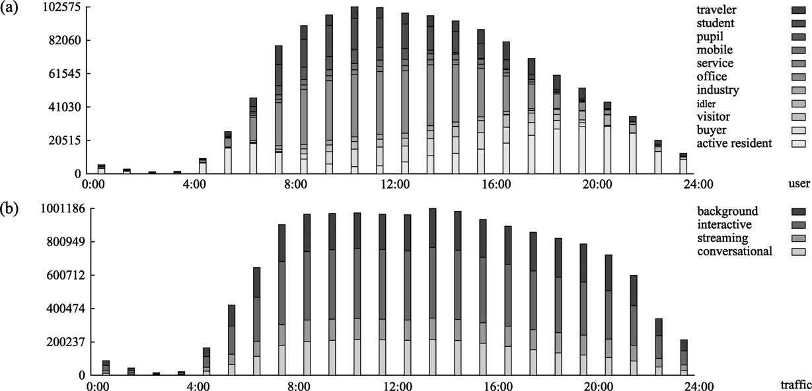
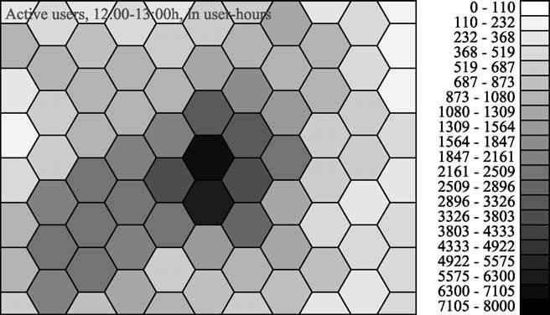

758

M. Hollick et al. / Computer Communications 27 (2004) 751–761

Fig. 4. (a) Summarized number of active users over time; (b) summarized workload over day (in kB/s).

secondary sources, which already interpreted these
studies. In addition, we have been able to access
trajectories of personal activities for various German
cities. These have been available upon request at the
municipality of Darmstadt for nonproﬁt use.
Using the above-mentioned sources, we have been able
to instantiate our model for Darmstadt, a German city of
around 145,000 inhabitants. We needed to perform
signiﬁcant post-processing. The zones available in the
zoning plan are for example of arbitrary shape and size
and needed to be manually processed to ﬁt the proposed
cell structure. Moreover, special locations have been
modeled using our intimate knowledge of the city.
Gathering data for these special places proved to be very
labor intensive.
Some graphical results of the instantiation are given
below. Fig. 3(b) shows the zoning plan of the modeled
area—the city center of Darmstadt. The arbitrary shape of
some zones (black) from census data is drawn alongside
with the cells (black hexagons) of our model and the base
stations of a currently deployed GSM network (white circles;
we use an approximated cell radius of 1.2 km to depict the
cell size).
A user activity chart for all users and user groups is
depicted in Fig. 4(a). It shows the summarized number of
active users over the day being modeled. We see low user
activity in the early morning. Starting from 4:00 h in the
morning, the number of active users increases as people get
ready for work or are on their way to work. From 8:00 h on
most people are up and active. We have observed that the
geographical distribution of user density changes
signiﬁcantly over day, due to the different activities pursued
by the different users. This shift in density can be seen
especially from residential areas to workplaces.
The decrease in the evening is not as abrupt as the increase

seen in the morning. Nevertheless, the focus is changed
from work to residential areas.
The combination of the user activity with the prediction
of the trafﬁc caused by this results in the summarized
workload which is illustrated in Fig. 4(b). Because users in
different classes produce different load, the peak trafﬁc
value does not correspond directly with the peak value of
user activity.
As we noted earlier, our trafﬁc distribution is dependent
on the geographical location. Fig. 5 presents the
corresponding density chart of user activity at cell level.
The depicted values account for the projected aggregated
user activity for all active users from 12:00 to 13:00 h.
The activity is given in user-hours. The city center of
Darmstadt consists of ofﬁce and shopping facilities and
large parts of the university while the region in the east is
mainly covered by industrial areas. It is clearly visible, that
the city center and the nearby university attract most of the
users. Fig. 6 shows the density of active residents for
the time period from 20:00 to 21:00 h. At that time, the main
residential areas are clearly visible in a belt surrounding

Fig. 5. Density of active users, 12:00 – 13:00 h (in user hours).

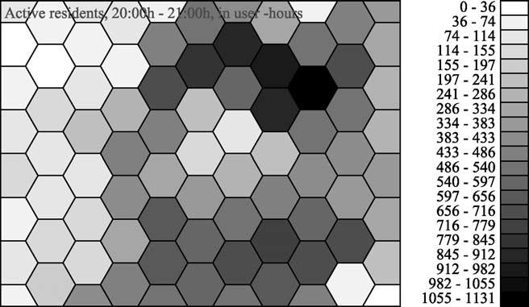
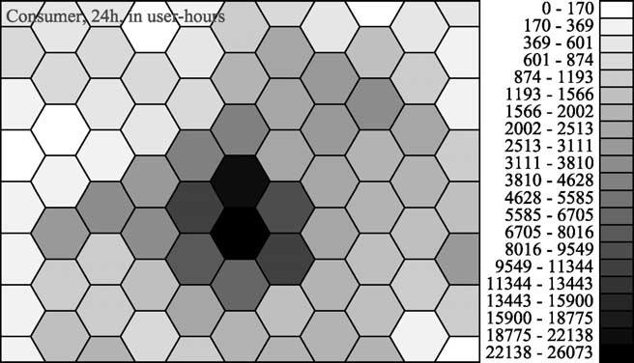
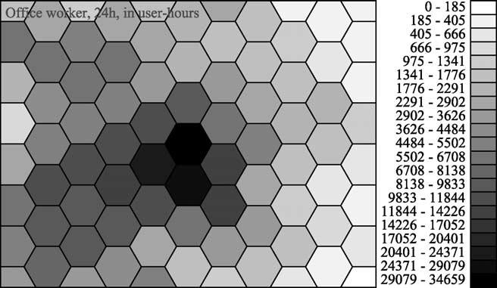
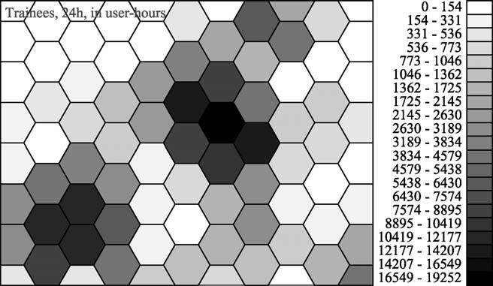

M. Hollick et al. / Computer Communications 27 (2004) 751–761

Fig. 6. Density of active residents, 20:00 – 21:00 h (in user hours). Fig. 8. Density of ofﬁce workers over 24 h (in user hours).

the center of the city and in the west of the city. The center 5.2. Application of the model
itself is only populated with few residents at the time of the

759

presented snapshot.
Investigation of the busy hour of the network for all
individual cells reveals, that within approximately 20% of
the area we expect roughly 50% of the active users
causing 44% of the total trafﬁc. Within approximately
50% of the area, we expect 78% of the active users
causing 76% of the total trafﬁc. This clearly backs our
initial assumption that the heterogeneity within fourth
generation networks demands for adequate access
technology like, for example, hot spots to provide for
high capacity within selected areas. An animation of the
time ﬂuctuation of the user, respectively, trafﬁc density
over day can be found at Ref. [4].
Figs. 7 – 9 depict the activity values of some selected
user groups for the complete day. While the consumers
(see Fig. 7) are concentrated in the shopping areas of the
city center, the ofﬁce workers (see Fig. 8) are spread over
the colocated ofﬁce buildings in the same area and the
district south east of the center. The image for the
trainees (see Fig. 9) shows a different distribution:
Darmstadt University of Technology, which is located
in the city center and Darmstadt University of Applied
Sciences located south east account for most activity
while the pupils are nearly uniformly distributed through-
out the city.

Fig. 7. Density of consumers over 24 h (in user hours).
We used the workload model to perform an experimental
analysis of a set of QoS routing protocols within a
prototypical metropolitan wireless RAN [33]. The goal was
to investigate the load-balancing capability of the routing
strategies studied. The investigation included combinations
out of the sets {static, dynamic}, {single-path, multi-path}
and {distance, delay} algorithms. We used ﬁve different
trafﬁc distributions (external vs. internal trafﬁc) with the four
trafﬁc classes {conversational, streaming, transactional,
background} from Ref. [9]. We built a proprietary simulation
environment which is based on ns-2 [34].
We now present some results of our study. The entire set
of results can be found in Ref. [33]. We compare the delay
of a measurement stream from a residential area to the city
center. Fig. 10 depicts the scatter-plot of the delay of
individual packets over 24 h for (a) a single-path algorithm
and (b) a multi-path algorithm. Packets, which are dropped,
are marked in gray. The single path algorithm ‘fails’ if the
backbone is under heavy load. The loss increases and the
delay is as high as 21 ms. The rise is relatively abrupt and
the decline is smoother. This is due to the trafﬁc load, which
is similarly shaped. The delay-constraint multi-path algor-
ithm has only short periods of time where the increase in
delay and loss is considerable, albeit a few packets reach a
delay of 33 ms due to the choice of prolonged paths.

Fig. 9. Density of trainees over 24 h (in user hours).

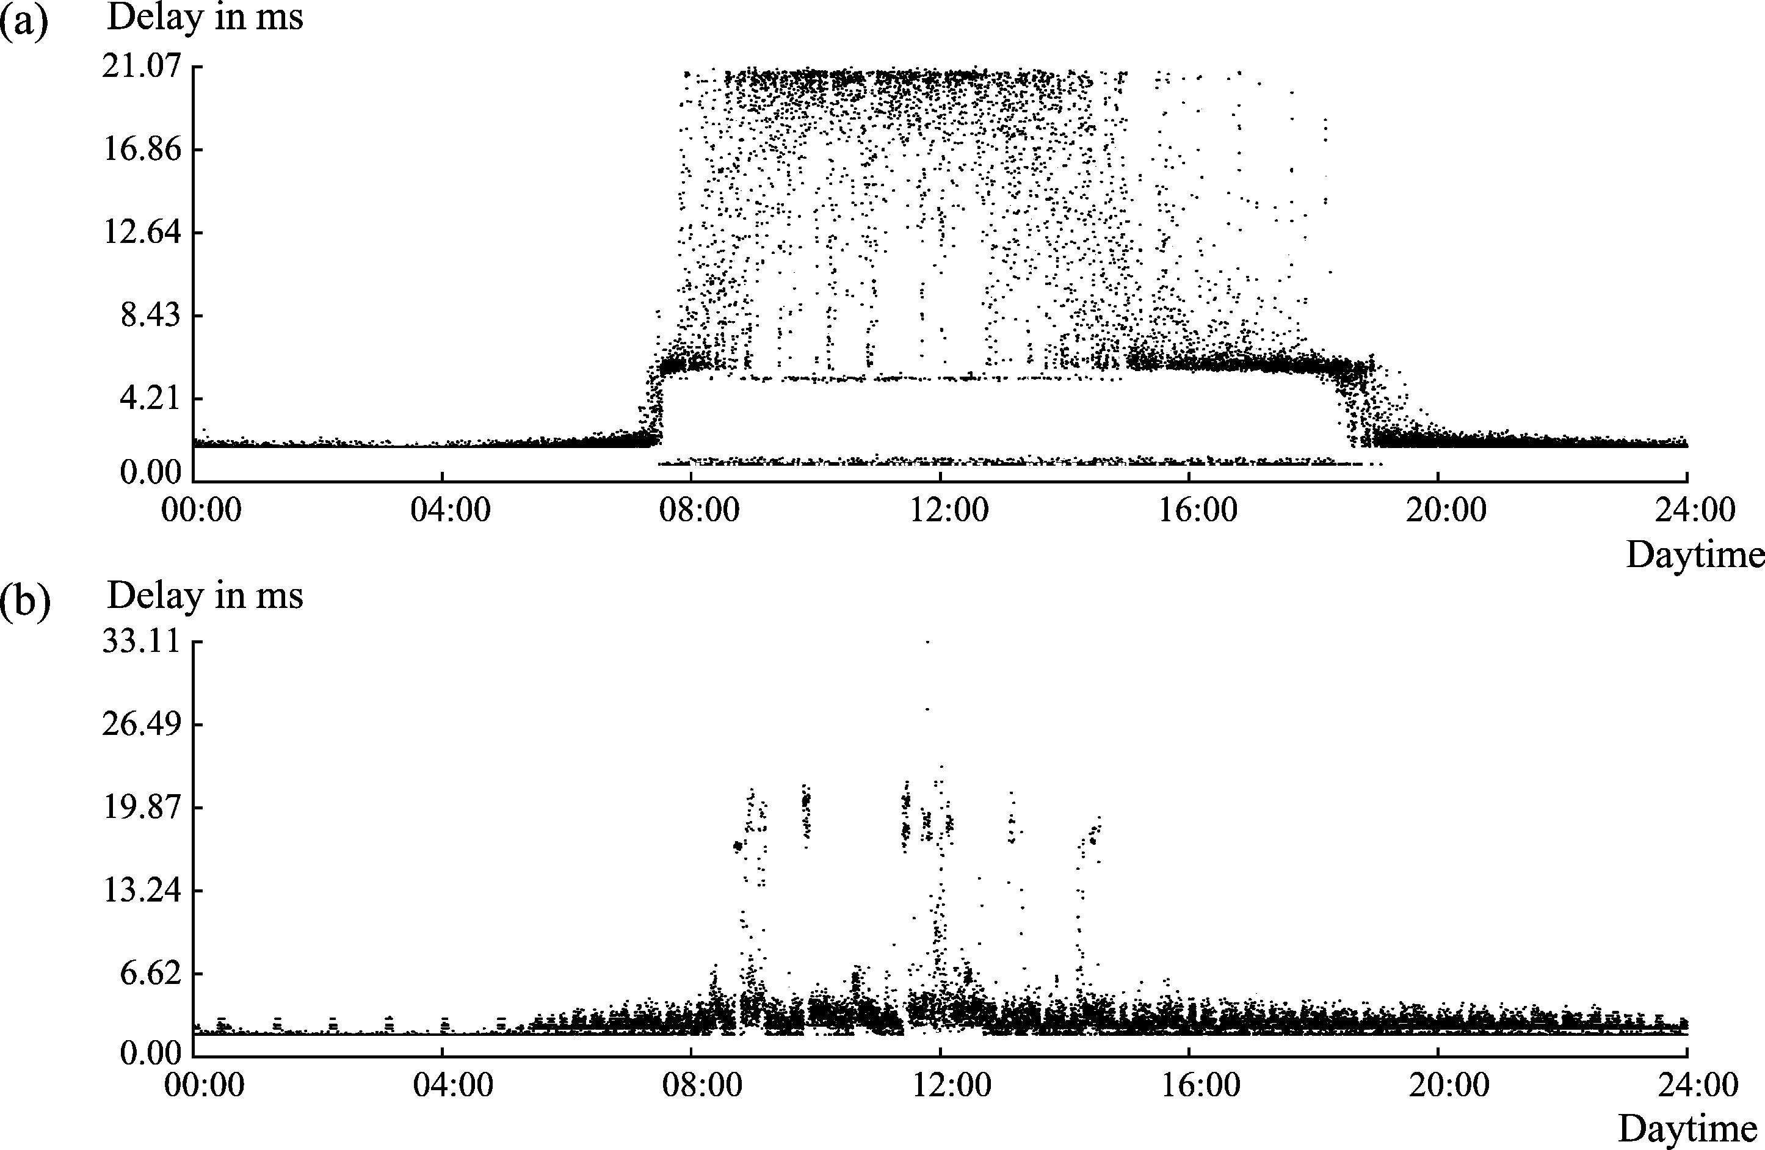

760

M. Hollick et al. / Computer Communications 27 (2004) 751–761

Fig. 10. Delay (in ms) of individual packets in a measurement ﬂow from a residential area to the city center: (a) shortest path algorithm; (b) delay constraint
multi-path algorithm.

6. Conclusions

We presented a novel approach towards a mobility model
based on statistical data collection covering the macroscopic
effects observed within metropolitan areas. After surveying
the current state of the art approaches towards mobility
modeling, we formulated a novel model to ﬁt the special
needs of metropolitan areas in the context of heterogeneous
wireless RANs.
Our model borrows from models used for transportation
planning while emphasizing the aspects needed for
investigations on trafﬁc related issues of wireless
communication networks. The fundamentals of this
model, the classiﬁcation of the locations as well as the
user behavior, have been described in detail.
Based on the above mentioned concepts, we derived and
explained the analytical description of our model. We gave
detailed deﬁnitions and equations to capture the model
prerequisites and to allow for easy instantiation.
Moreover, we gave information necessary to augment the
results of the mobility model with trafﬁc predictions to form
a workload model for wireless metropolitan area networks.
A transformation of the results to ﬁt a cell-based networking
infrastructure was presented, too.
In related work, we applied our model to serve as
workload for a comparative analysis of quality of service
routing strategies in wireless metropolitan area networks.
The results of the investigation are based on the instantiation
of our model for Darmstadt [32] and can be found in
Ref. [33]. Lessons learned with respect to the instantiation
of our model include that data which was not intended to
serve as a basis for network trafﬁc analysis needs signiﬁcant

post-processing, depending on the granularity of data
available.
We perceive the combination of our approach with
microscopic synthetic models as a further interesting
research direction. One possible application would be the
modeling of large-scale metropolitan ad hoc networks.
The major advantage of such a model being the realism for
both, microscopic and macroscopic analysis.

Acknowledgements

We acknowledge the help of the statistics department at
the municipality of Darmstadt, City of Science. Many thanks
go to Nicole Karsten-Berier and Joachim Sokol for initial
stimulating discussion.

References

[1] Z. Wang, J. Crowcroft, Quality-of-service routing for supporting
multimedia applications, IEEE Journal of Selected Areas in
Communications 14 (7) (1996) 1228 – 1234.
[2] S. Chen, K. Nahrstedt, An overview of quality-of-service routing for
the next generation high-speed networks: problems and solutions,
IEEE Network Magazine, Special Issue on Transmission and
Distribution of Digital Video 12 (6) (1998) 64 – 79.
[3] J.L. Sobrinho, Algebra and algorithms for QoS path computation and
hop-by-hop routing in the Internet, In Proceedings of the 20th Annual
Joint Conference of the IEEE Computer and Communications
Societies (INFOCOM)’01, Anchorage, AK, USA, vol. 2, April
2001, pp. 727 – 735.
[4] M. Hollick, J. Schmitt, H.-P. Huth, J. Sokol, MobQoS-Mobility
Aware QoS Routing, August 2003, Available at http://www.kom.
tu-darmstadt.de/Research/MobQoS/

M. Hollick et al. / Computer Communications 27 (2004) 751–761

761

[5] C. Perkins, IP Mobility Support for IPv4, Proposed Standard RFC
3344, August 2002.
[6] D.B. Johnson, C.E. Perkins, J. Arkko, IP Mobility Support in IPv6,
Internet Draft draft-ietf-mobileip-ipv6-19.txt, October 2002.
[7] G. Huston, Next Steps for the IP QoS Architecture, Informational
RFC 2290, November 2000.
[8] D.O. Awduche, A. Chiu, A. Elwalid, I. Widjaja, X. Xiao, Overview
and Principles of Internet Trafﬁc Engineering, Informational RFC
3272, May 2002.
[9] 3GPP, QoS Concept and Architecture TS 23.107, Release 5, version
5.9.0, June 2003.
[10] C. Bettstetter, Mobility modeling in wireless networks: categoriz-
ation, smooth movement, and border effects, ACM SIGMOBILE
Mobile Computing and Communications Review 5 (3) (2001)
55 – 66.
[11] T. Camp, J. Boleng, V. Davies, A survey of mobility models for ad
hoc network research, Wireless Communications and Mobile
Computing (WCMC): Special issue on Mobile Ad Hoc Networking:
Research, Trends and Applications 2 (5) (2002) 483 – 502.
[12] M.M. Zonoozi, P. Dassanayake, User mobility modeling and
characterization of mobility patterns, IEEE Journal on Selected
Areas in Communications 15 (7) (1997) 1239 – 1252.
[13] J. Yoon, M. Liu, B. Noble, Random waypoint considered harmful, In
Proceedings of the 22nd Annual Joint Conference of the IEEE
Computer and Communications Societies IEEE INFOCOM, 2003,
San Francisco, CA, USA, April 2003, pp. 1312 – 1321.
[14] X. Hong, M. Gerla, G. Pei, C.-C. Chiang, A group mobility model for
ad hoc wireless networks, In Proceedings of ACM International
Workshop on Modeling Analysis and Simulation of Wireless and
Mobile Systems, MSWiM’99, Seattle, WA, USA, August 1999,
pp. 53 – 60.
[15] C. Bettstetter, H. Hartenstein, X. Pe`rez-Costa, Stochastic properties of
the random waypoint mobility model: epoch length, direction
distribution, and cell change rate, In Proceedings of the ﬁfth ACM
International Workshop on Modeling Analysis and Simulation of
Wireless and Mobile Systems 2002, Atlanta, Georgia, USA, ACM
Press, New York, 2002, pp. 7 – 14.
[16] Los Alamos National Laboratory, TRansportation ANalysis SIMu-
lation System (2003), Available at http://transims.tsasa.lanl.gov/
[17] D. Lam, D.C. Cox, J. Wilson, Teletrafﬁc modeling for personal
communication services, IEEE Communications Magazine 35 (2)
(1997) 79 – 87.
[18] S. Nanda, Teletrafﬁc models for urban and suburban microcells: cell
sizes and handoff rates, IEEE Transactions on Vehicular Technology
42 (4) (1993) 673 – 682.
[19] J. Scourias, T. Kunz, Activity-based mobility modeling: realistic
evaluation of location management schemes for cellular networks, In
Proceedings of Wireless Communications and Networking Con-
ference, WCNC 1999, New Orleans, LA, USA, IEEE, September
1999, pp. 296 – 300.
[20] M.N. Rocha, G.R. Mateus, S.L. da Silva, QoS and simulation models
in mobile communication networks, In Proceedings of ACM

International Workshop on Modeling Analysis and Simulation of
Wireless and Mobile Systems MSWiM 2000, Boston, MA, USA,
August 2000, pp. 119 – 122.
[21] J. Markoulidakis, G. Lyberopoulos, M. Anagnostou, Trafﬁc model for
third generation cellular mobile telecommunication systems, Wireless
Networks 4 (1998) 389 – 400.
[22] J. Markoulidakis, G. Lyberopoulos, D. Tsirkas, E. Sykas, Mobility
modeling in third-generation mobile telecommunications systems,
IEEE Personal Communications 4 (4) (1997) 41 – 56.
[23] D. Hong, S.S. Rappaport, Trafﬁc model and performance analysis for
cellular mobile radio telephone systems with prioritized and non-
prioritized handoff procedures, IEEE Transactions on Vehicular
Technology 35 (3) (1986) 77 – 92.
[24] P. Camarda, G. Schiraldi, F. Talucci, Mobility modeling in cellular
communication networks, In Proceedings of 21st IEEE Conference on
Local Computer Networks, 1996 Minneapolis, MN, USA, IEEE,
October 1996, pp. 518 – 525.
[25] E. Jugl, H. Boche, A new mobility model for performance evaluation
of future mobile communication systems, In Proceedings of IEEE
International Conference on Communications. ICC’99, Vancouver,
BC, Canada, June 1999, pp. 1751 – 1755.
[26] Y.-C. Tseng, L.-W. Chen, M.-H. Yang, J.-J. Wu, A stop-or-move
mobility model for pcs networks and its location-tracking strategies,
Computer Communications 26 (12) (2003) 1288 – 1301.
[27] D. Tang, M. Baker, Analysis of a metropolitan-area wireless network,
Wireless Networks 8 (2002) 107 – 120.
[28] D. Kotz, K. Essien, Analysis of a campus-wide wireless network, In
Proceedings of Eighth Annual International Conference on Mobile
Computing and Networking (ACM MOBICOM)’02, Atlanta, GA,
USA, September 2002, pp. 107 – 118.
[29] A. Balachandran, G. Voelker, P. Bahl, P.V. Rangan, Characterizing
user behavior and network performance in a public wireless LAN,
ACM SIGMETRICS Performance Evaluation Review 30 (1) (2002)
195 – 205.
[30] E. Beimborn, R. Kennedy, W. Schaefer, Inside the Blackbox: Making
Transportation Models Work for Livable Communities, 1996,
Available at http://www.environmentaldefense.org/documents/
1859_InsideBlackBox.pdf
[31] J.-P. Rodrigue, Transport geography on the web, 1998, Available at
http://people.hofstra.edu/geotrans/
[32] M. Hollick, T. Krop, J. Schmitt, H.-P. Huth, R. Steinmetz, A hybrid
workload model for wireless metropolitan area networks, In
Proceedings of 58th IEEE Vehicular Technology Conference,
VTC’03-Fall, Orlando, FL, USA, October 2003.
[33] M. Hollick, T. Krop, J. Schmitt, H.-P. Huth, R. Steinmetz,
Comparative analysis of quality of service routing in wireless
metropolitan area networks, In Proceedings of 28th Annual IEEE
International Conference on Local Computer Networks, LCN’03,
Bonn, Germany, October 2003, pp. 470 – 479.
[34] K. Fall, K. Varadhan. The ns Manual, 2002, Software and manual
available at http://www.isi.edu/nsnam/ns/.

